**Preprocessing:**

Since the dataset of MINIST was quite large, I had to use Pandas module to make the process of reading the dataset quicker. However, Pandas only works with numerical values. As the dataset of Iris flower had alphabetical class labels, I had to assign numerical values to each class label.

|  |  |
| --- | --- |
| I. setosa | 1 |
| I. versicolor | 2 |
| I. virginica | 3 |

**Program Results:**

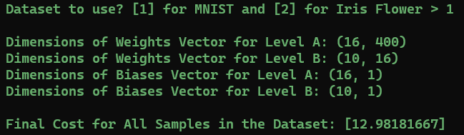

First screenshot shows the results of FFNN with MINIST dataset. It displays the dimensions of weights vectors and biases vector. Level A represents parameters between input layer and hidden layer. Level B represents parameters between hidden layer and output layer.

Finally the program displays the Mean Squared Error of all samples for single iteration, i.e. **12.98.**

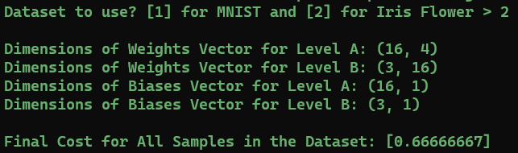

Second screenshot shows the results of FFNN with Iris flower dataset. It displays the dimensions of weights vectors and biases vector. We had 4 features and 16 perceptrons in hidden layer so the dimensions are accordingly. Class labels for this dataset were 3 so the dimensions of second weights vector is 3 by 16.

Finally the program displays the Mean Squared Error of all samples for single iteration, i.e. **0.666.**